


Prepared for
moira zelinga | lecturer | mgt326 | strategic supply chain management | usc

Prepared by
word count: 621
SUPPLY CHAIN STRATEGY MODEL

1. AgSolutions Australia: Company and product overview
AgSolutions is a Gympie-based company producing soil regeneration and livestock nutrition solutions for Australian farmers (AG Solutions 2017a). CEO, Julie Williams, strives to continuously improve business efficiencies and eliminate resource wastefulness by embracing Kaizen ideologies and lean principles (AgSolutions 2017b; CEO personal correspondence, 6 February 2020). Kaizen philosophy infers production excellence can be achieved through continuous improvement of organisational processes and procedures, practiced by all employees across every facet of the business (Dimitrescu, et al. 2018). Such practices are evident across the AgSolutions supply chain (SC) whereby continuous effort is made by all employees to improve or eliminate non-value processes along the chain and during production through Kanban carding and Just-in-time (JIT) manufacturing (AG Solutions 2020 & Production Coordinator personal correspondence and observation, 3 March 2020). This suggests the organisation practices lean manufacturing (Chiarini, Baccarani & Mascherpa 2018; Dimitrescu, et al 2018) and lean supply chain management (SCM) (Ciccullo, et al. 2018). Using the MegaMin Loose Supplement Mineral Blend (MLSMB) product, identified in Figure 1, this report will identify SC strategy drivers and potential challenges by developing a high-level model incorporating probable end-to-end flow of goods and services across the product SC; including process, information, and financial flows.

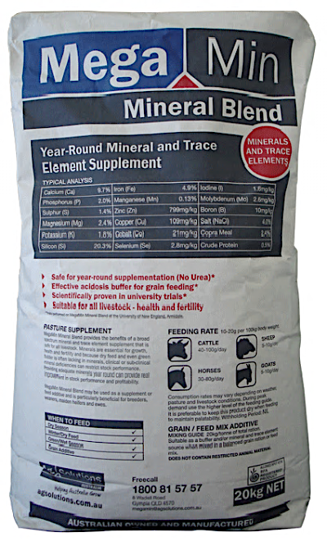
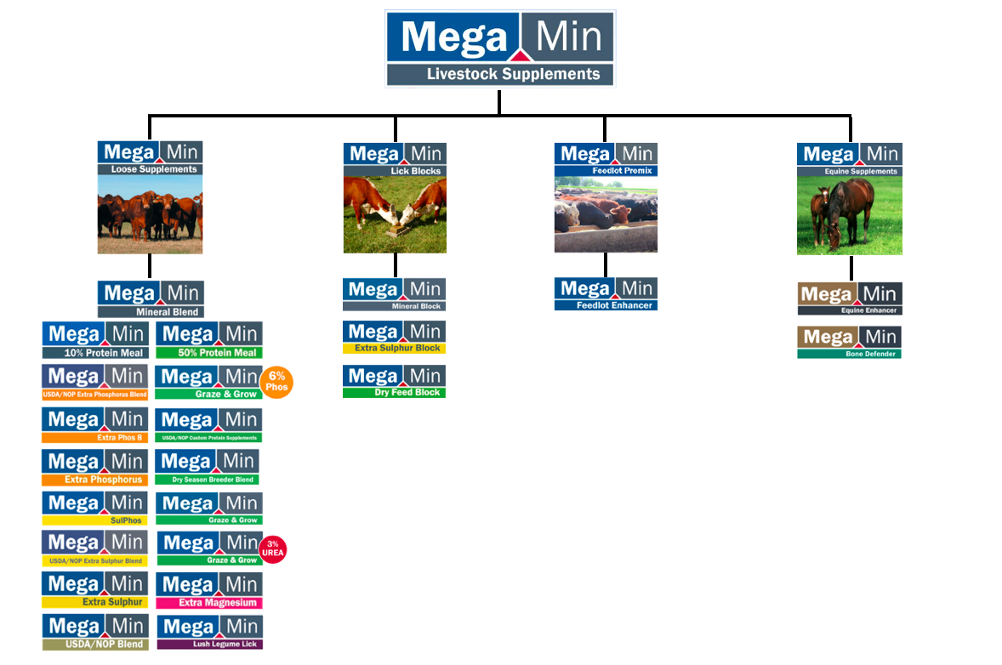
Figure 1: Megamin Livestock Supplement product line and Mineral Blend product, adapted from AG Solutions (2017).

2. AgSolutions’ MLSMB supply chain
Appendix A comprises a SC network map for AgSolutions MLSMB product; this map underpins the more complex supply network illustrated in Figure 2, which identifies inbound logistics between upstream suppliers and focal firm, AgSolutions, alongside outbound logistics involving downstream customers (Ayantoyinbo & Gegeleso 2018; Harrison, Skipworth & Van 2019). Supply chain logistics encompass the flow of information and materials across supply networks (Sauer & Seuring 2019); information flows up and down the supply chain to facilitate timely processes and network allocation of adequate resources relative to consumer demand, while materials commence flow through upstream suppliers as raw materials (inputs) before transitioning into saleable goods and services (outputs) for consumption by downstream end-customers (Harrison, Skipworth & Van 2019; Sauer & Seuring 2019).

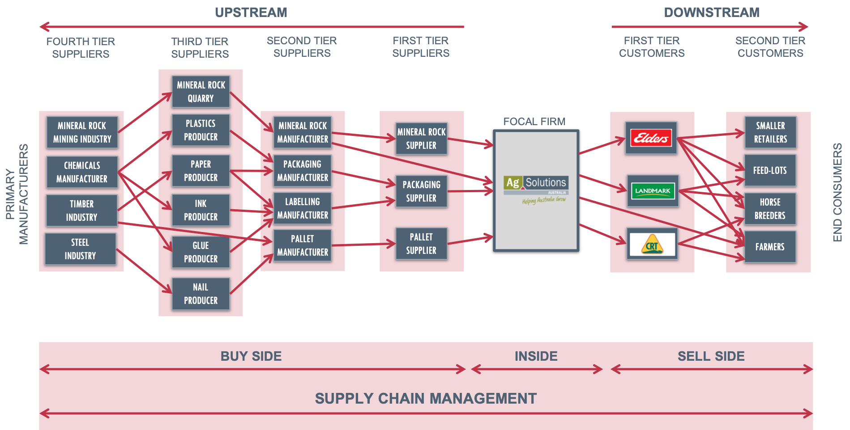
Figure 2: AgSolutions Supply Network sourced through Williams, P. Production Coordinator personal correspondence 3 March 2020, adapted from After Slack, et al. 1997, cited in Harrison, Skipworth & Van 2019

Based on the logistics exemplified between third-tier mineral rock quarry suppliers, the focal firm, and second tier end customers in Figure 2, an MLSMB end-to-end product supply chain has been developed in Figure 3 to demonstrate the upstream and downstream supply chain processes and logistics for AgSolutions, including how consumer demand stimulates informational, material and financial flows across the chain.

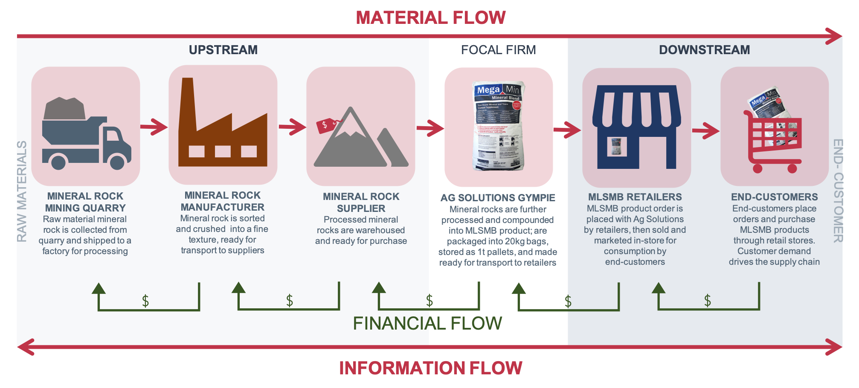
Figure 3: Supply Chain material, information and financial flows, ,
adapted from Harrison, Skipworth & Van 2019

Financial flow encompasses three ratios that can impact SC efficiencies, including; 1) Settlement period for accounts payable from AgSolutions to upstream suppliers; 2) Inventory turnover relative to cost of goods sold by AgSolutions; and 3) Settlement period for AgSolutions’ accounts receivable, being downstream end customers (Liu, et al. 2019). Managing financial flows and conducting adequate ratio analysis facilitates SC efficiencies through cash flow and liquidity optimisation (Liu, et al. 2019). Examples of additional strategy drivers in the macro and micro environment that can positively or negatively affect AgSolutions’ SC, include; seasonal changes, whereby MLSMB consumer demand and production volumes increase during draught and decrease during wet seasons (Production Coordinator personal correspondence, 3 March 2020); or strategic capabilities for maintaining competitive advantage and meeting consumer demand through effective SCM pertaining to lead times, production value, quality assurance, deliverability and acquisition of adequate resources (Datta 2017; Harrison, Skipworth & Van 2019), such as scarce mineral compounds or raw materials (Production Coordinator personal correspondence, 3 March 2020).

3. Potential challenges
Figure 4 demonstrates how information systems underpin SC alignment with strategic objectives (Gattorna 2016) and identifies how AgSolutions’ CEO leadership commitment to kaizen philosophies and lean principles likely influence capabilities for implementing SC strategies to meet market demand. For example, AgSolutions’ SC capabilities are influenced by information systems that rely on lean practices (Production Coordinator personal correspondence and observation, 3 March 2020), such as manual Kanban carding systems, that facilitate JIT production (Dimitrescu, et al 2018; Production Coordinator personal correspondence and observation, 3 March 2020 ).

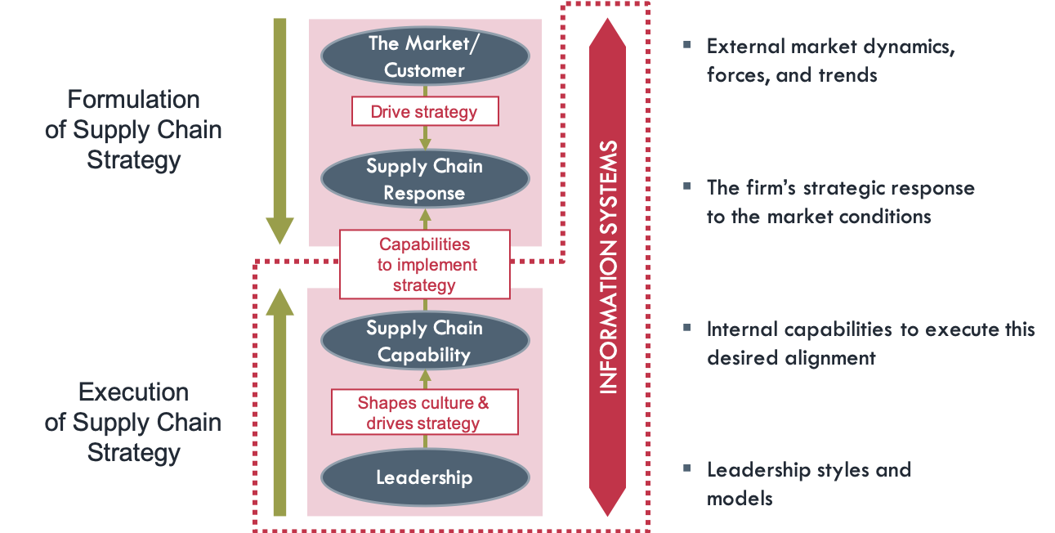
Figure 4: Supply Chain Alignment model, adapted from Gattorna 2016

AgSolutions’ lean SCM approach identifies potential challenges whereby manual information systems determine stock level accuracy, increasing human error susceptibility when compared to digital systems. As exemplified in Figure 5, such microenvironmental challenges can impact SC logistics and in turn financial flow and return on investment (ROI) potentials (Christopher 2005; Liu, et al. 2019) as unaccounted for excess inventory, determined by an inaccurate manual information system, can increase downstream storage costs in the SC, reducing cash flow, liquidity and ROI (Christopher 2005;Liu, et al. 2019). Alternatively, insufficient inventory could impact capabilities for implementing JIT SC strategies, resulting in lost sales that could negatively impact AgSolutions’ bottom line (Christopher 2005).
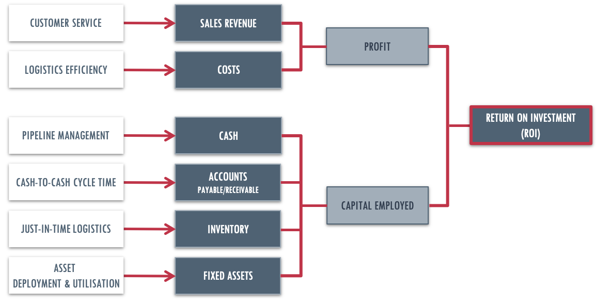
Figure 5: Logistics impact on ROI, adapted from Christopher 2005

4. Conclusion
Findings suggest AgSolutions’ SC efficiencies could be improved through implementation of digital information systems.

References
AG Solutions 2017a, Our Company, viewed 6th February 2020, https://agsolutions.com.au/our-company/
AG Solutions 2017b, Leadership, viewed 6th February 2020, https://agsolutions.com.au/our-company/our-team/leadership/
AG Solutions 2020, Student Handbook, Ag Solutions Australia, Gympie.
Ayantoyinbo, BB & Gegeleso, OM 2018, ‘Impact of inbound and outbound logistics services on small scale business’, Transport and Logistics, vol. 18, no. 44, pp. 69-76.
Chiarini, A, Baccarani, C & Mascherpa, V 2018, ‘Lean production, Toyota Production System and Kaizen philosophy’, The TQM Journal, vol. 30, no. 4, pp. 425-438, doi: 10.1108/TQM-12-2017-0178
Christopher, M 2005, Logistics and Supply Chain Management: Creating value-adding networks, 3rd edn, Prentice Hall Financial Times, Pearson Education, Harlow.
Ciccullo, F, Pero, M, Caridi, M, Gosling, J & Purvis, L 2018, ‘Integrating the environmental and social sustainability pillars into the lean and agile supply chain management paradigms: A literature review and future research directions’, Journal of Cleaner Production, vol. 172, pg. 2336-2350, doi: 10.1016/j.jclepro.2017.11.176
Datta, PP 2017, ‘Enhancing competitive advantage by constructing supply chains to achieve superior performance’, Production Planning & Control, vol. 28, no.1, pp.57-74, doi: 10.1080/09537287.2016.1231854
Dimitrescu, A, Alecusan, A, Babis, C, Niculae Banica, E & Dascalu, L 2018, ‘Elimination of losses used lean manufacturing techniques and Kaizen philosophy’, Fiabilitate şi Durabilitate, vol. 2, no. 22, pp. 58-64.
Gattorna, J 2016, Dynamic supply chain alignment: a new business model for peak performance in enterprise supply chains across all geographies, Routledge, New York.
Harrison, A, Skipworth, H, & Van, H 2019, Logistics management and strategy: Competing through the supply chain, 6th edn, Pearson Education Limited, Harlow.
LeMay, S, Helms, MM, Kimball, B & McMahon, D 2017, ‘Supply chain management: The elusive concept and definition’, The International Journal of Logistics Management, vol. 28, no. 4, pp. 1425-1453, doi: 10.1108/IJLM-10-2016-0232
Liu, Q, Rezaei, AR, Wong, KY & Azami, MM 2019, ‘Integrated modeling and optimization of material flow and financial flow of supply chain network considering financial ratios’, Numerical Algebra, Control & Optimization, vol. 9, no. 2, pp. 113-132, doi: 10.3934/naco.2019009
Sauer, PC & Seuring, S 2019, ‘Extending the reach of multi-tier sustainable supply chain management – Insights from mineral supply chains’, International Journal of Production Economics, vol. 217, pp. 31-43, doi: 10.1016/j.ijpe.2018.05.030

Appendices

Appendix A: AgSolutions’ MLSMB product supply chain network map

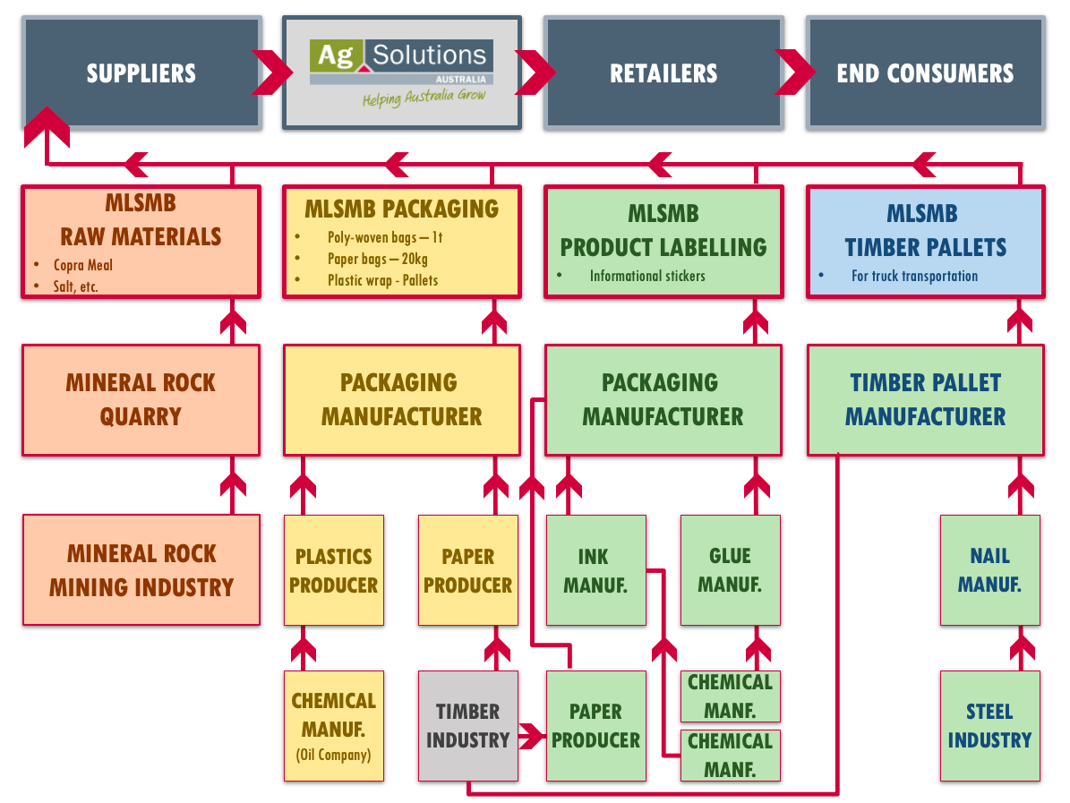
Figure 6: AgSolutions' MLSMB product supply chain, adapted from Zheng, et al. 1998, cited in Harrison, Skipworth & Van 2019; information sourced from AG Solutions 2017 & Williams, P. Production Coordinator personal correspondence, 3 March 2020,

